**Programming Questions # 2**

**Deadline: 18-Dec-2021**

1. Write a C / C++ program which should read the n number of integers from the user and output total number of possible group (s) of two integer values if difference between two integer’s values is greater than their product to the power of total integer values but should be less than total number of palindromes in two different arrays of characters which are having odd and even strings simultaneously, in either case total sum of character values (Ascii values) of 2 arrays should be displayed as output only and only if the sum is less than total number of integers minus total number of characters in the two arrays.
2. Write a C/C++ Program which should count the total number of vowel in the palindromes (if any) in an array and if the total number of vowels exceed total number of palindromes than create another array of character which should replace first vowel in first palindrome with last vowel in last palindrome and second palindrome in with second last and so on, in the end display the largest palindrome string with minimum number of vowels in Ascii values.
3. Convert a non-negative integer to its English words representation and print in reverse if total characters in English words are more than total words in a sentence.
4. Given an input n, count the total number of digit 1 appearing in all non-negative integers less than or equal to n.

For example:  
Given n = 13,  
Return 6, because digit 1 occurred in the following numbers: 1, 10, 11, 12, 13.

1. Given an array, Rotate (shift left) an array of n elements to the right by k steps.

For example, with n = 7 and k = 3, the array [1,2,3,4,5,6,7] is rotated to [5,6,7,1,2,3,4].

After rotating the array add in into another array and display array index with minumum value if the sum of all the indexes having odd values is greater than sum of all the indexes having even values otherwise write all odd values in the text file and create linked list of all odd values using pointers.

1. You are given an *n* x *n* 2D matrix representing an image.

Rotate the image by 180 degrees (anti-clockwise) but after sorting the n*n 2D array

1. Given a string containing just the characters '(' and ')', find the length of the longest and shortest valid (well-formed) parentheses substring.

For "(()", the longest valid parentheses substring is "()", which has length = 2.

Another example is ")()())", where the longest valid parentheses substring is "()()", which has length = 4.

1. Write a program which should evaluate a given mathematical expression , hint you need use Stack

For Example: (2+3) -2 + (3*2) = 5-2+6= 9

1. Write a program which receive two strings and check whether there are atleast two substrings in string-1, if there are then swap their order within String-1
2. Write a program to convert binary to octal and then octal to hex and hex to decimal. Input will be given in binary. There should be delay of 3 seconds in between every conversion. No built –in function should be used.
3. Write a program to calculate GPA of the semester, assuming there are 5 courses and each course is having following break-up:

Mid-Term Marks: 35

Final: 50

Quiz: 5

Assignment: 10

1. A 3x3 normal magic square is a 3x3 grid where the numbers on each row, each column, and both diagonals all add up to the same number, and the square contains the numbers 1 to 9 exactly.

4 9 2  
3 5 7  
8 1 6

Implement a function which, given a two-dimensional 3 by 3 array of ints returns a Boolean that tells us if the given square (represented by the array) is a normal 3 by 3 magic square or not.

1. Write a program which should traverse given 20 values using Binary Tree.
2. If we list all the natural numbers below 10 that are multiples of 3 or 5, we get 3, 5, 6 and 9. The sum of these multiples is 23. Find the sum of all the multiples of 3 or 5 below 1000.
3. Given a list of 100 values, write a program which should display largest possible sum out of 100 values
4. A palindromic number reads the same both ways. The largest palindrome made from the product of two 2-digit numbers is 9009 = 91 × 99.

Find the largest palindrome made from the product of two digit and 3-digit numbers.

1. Given the Periodic table below, generate all possible combination of chemicals which are having atomic number greater than their immediate below chemical by difference of 15 to 20% at max, to the right the difference should not be more than 20% from that of immediately below and 10% at max from the difference from the left. All those chemicals should be displayed in sequence with increasing sum of atomic number of chemical created.

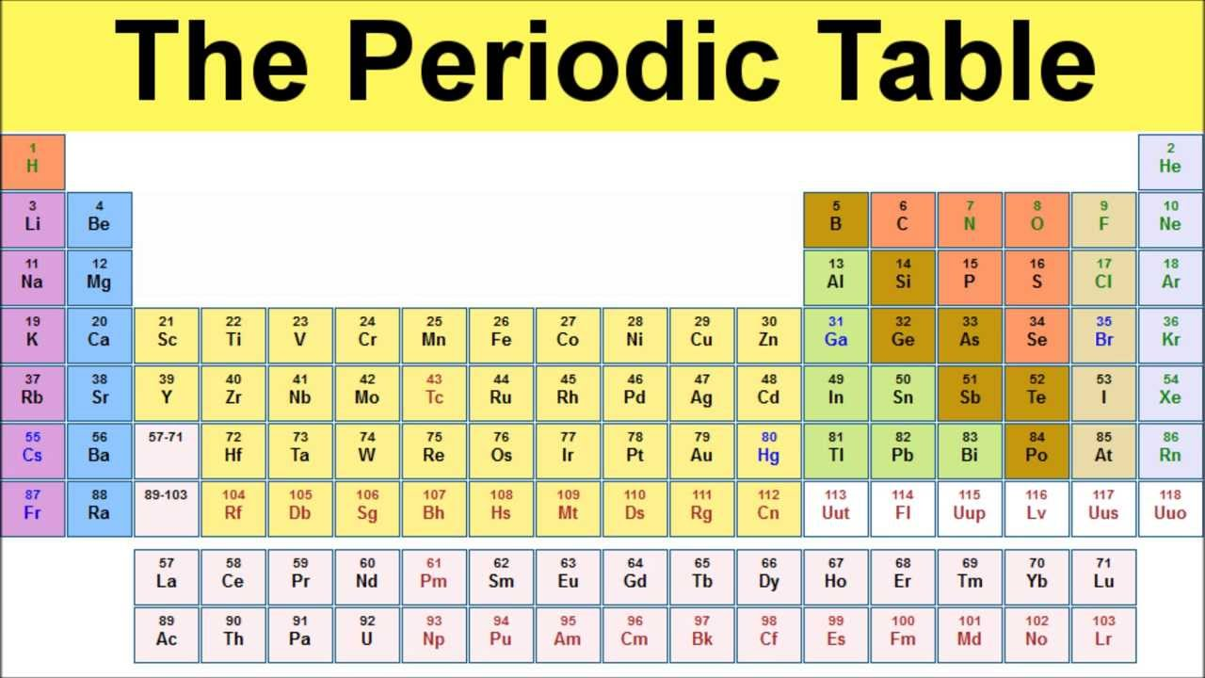

1. Write a Program which should read two files and should display the paragraphs which are having in common at least 3-sequence of consecutive characters having sum of characters more than 300 and difference should not be less than 30% of their sum.